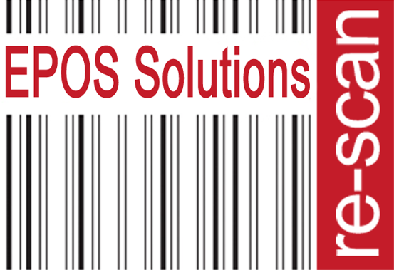 Covid 19 Risk Assessment -May 2020
What Are  The Hazards? | Who might be harmed | Controls Required | Additional Controls
Spread Of Covid-19 Coronavirus | Staff, whether on site, working from home or at customer premises  Customers and Visitors to our premises  Cleaners  Contractors  Drivers  Vulnerable groups – Elderly or Pregnant workers or staff with existing underlying health conditions.  Anyone else who physically comes in contact with us in relation to our business premises. | Hand Washing  Hand washing facilities with soap and water in place.  Stringent hand washing taking place.  Drying of hands with disposable paper towels where possible.  Sanitisers are available in all areas where washing facilities not readily available  Cleaning  Frequently cleaning and disinfecting objects and surfaces that are touched regularly particularly in areas of high use such as door handles, light switches, reception area using appropriate cleaning products and methods.  Social Distancing  Social Distancing -Reducing the number of persons in any work area to comply with the 2-metre gap recommended by the Public Health Agency.  Where possible take steps to review work schedules including start & finish times/shift patterns, working from home etc. to reduce number of workers on site at any one time. Also relocating workers to other tasks.  Redesigning processes to ensure social distancing in place.  Conference calls to be used instead of face to face meetings.  Ensuring sufficient rest breaks for staff.  Social distancing also to be adhered to in canteen area and smoking area.  Wearing of Gloves  Where Risk Assessment identifies wearing of gloves as a requirement of the job, an adequate supply of these will be provided. Staff will be instructed on how to remove gloves carefully to reduce contamination and how to dispose of them safely.  PPE – Personal Protective Equipment  Where PPE is a requirement for risks associated with the work undertaken the following measures will be followed-  Symptoms of Covid-19  If anyone becomes unwell with a new continuous cough or a high temperature in the workplace they will be sent home and advised to follow the stay at home guidance.  The HR team will maintain regular contact with staff members during this time.  If advised that a member of staff or public has developed Covid-19 and were recently on our premises the management team of the workplace will contact the Public Health Authority to discuss the case, identify people who have been in contact with them and will take advice on any actions or precautions that should be taken.  Drivers  Persons should avoid sharing vehicles or cabs, where suitable social distancing cannot be achieved.  Mental Health  Management will promote mental health & wellbeing awareness to staff during the Coronavirus outbreak and will offer whatever support they can to help.  Remote Working | Employees to be reminded on a regular basis to wash their hands for 20 seconds with water and soap and the importance of proper drying with disposable towels.  Liquid soap along with packs of disposable paper towels or rolls of blue paper towel will be made available by the company for use in all hand washing areas.  Bottles of hand sanitiser have been made available in all areas.  All staff to be reminded to catch coughs and sneezes in tissues – Follow Catch it, Bin it, Kill it, and to avoid touching face, eyes, nose or mouth with unclean hands.  To help reduce the spread of coronavirus (COVID-19) keep reminding everyone of all updated public health advice.  Ensure that any posters, leaflets and other advisory materials we have are displayed accordingly at all places of work.  All staff should as a minimum of once a day clean and sanitise their personal work space and equipment.  Regular checks will be carried out by managers/supervisors to ensure that the necessary procedures are being followed.  Staff to be reminded on a daily basis of the importance of social distancing both in the workplace and outside of it.  Areas used by customers, visitors etc. should be clearly marked with black and yellow floor tape along with associated signage to outline the recommended 2 metre exclusion areas for social distancing.  Staff to ensure that when using shared spaces such as designated smoking areas, locker rooms, canteen and kitchen areas, recommended social distancing measures should be paramount at all times, it is everyone’s responsibility to ensure this happens.  Management checks to ensure this is adhered to at all times.  Nitrile gloves are supplied by the company for staff to use if they wish.  Staff to be reminded that wearing of gloves is not a substitute for good hand washing or hand sanitising.  Where possible staff using hand held devices (RF guns, EPOD’s) should be allocated a specific device which they are responsible for keeping clean and sanitised in an attempt to avoid cross contamination.  To minimise the risk of transmission of COVID-19, face masks and visors are supplied by the company for staff to use if they wish.  All staff are required to report when allocated stocks pf PPE, washing and sanitising materials are running low in order to ensure they can be replenished before they run out.  Internal communication channels and cascading of messages through line managers will be carried out regularly to reassure and support employees in a fast changing situation.  The HR team along with line managers will offer support to staff who are adversely affected by Coronavirus or has a family member affected.  We will communicate with companies/stores we deliver to and collect from, in an effort to ensure welfare facilities will be available to our staff. We will offer the same facilities for operatives delivering to Dee Bee / ReScan offices if required.  If a second operative is required on certain installs, we will as far as is practicable try to ensure that the same people work together as much as possible.  Where practicable we will allocate a driver to a specific vehicle for as long a period as possible to allow the driver(s) to keep their working areas clean and sanitised.  As a business we are proactive in promoting regular communication of mental health information via notice boards and newsletters etc., and our HR team offer an open door policy for those who may need additional support.  When working away from the office ReScan operatives must ensure that they have taken enough PPE to ensure they are protecting themselves as far as is practicable for the duration of their site visit(s).

